User Manual Portal

By : Pitani Nitin Srichakri

**Objective and Scope:**Streamline the process of obtaining managerial approval for user manuals and logic documents and provide a portal for end users to access these documents.

**Process Description:**

* Users must sign up using an email ending with the company’s domain.
* By default, new users are classified as end users.
* Users log in with credentials.
* Each user’s type is associated with their account, determining their access level.
* Each Project will have a name which signifies its functionality and will be unique.
* Search Feature for effortless retrieval of a project with sorting feature with options of creation date, last updated, and alphabetical both ascending and descending.

Admin Processes:

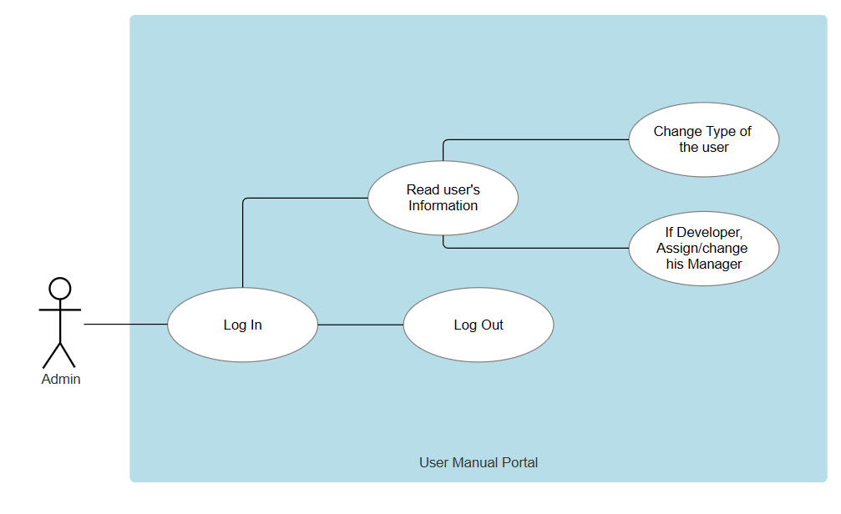

End User Processes:

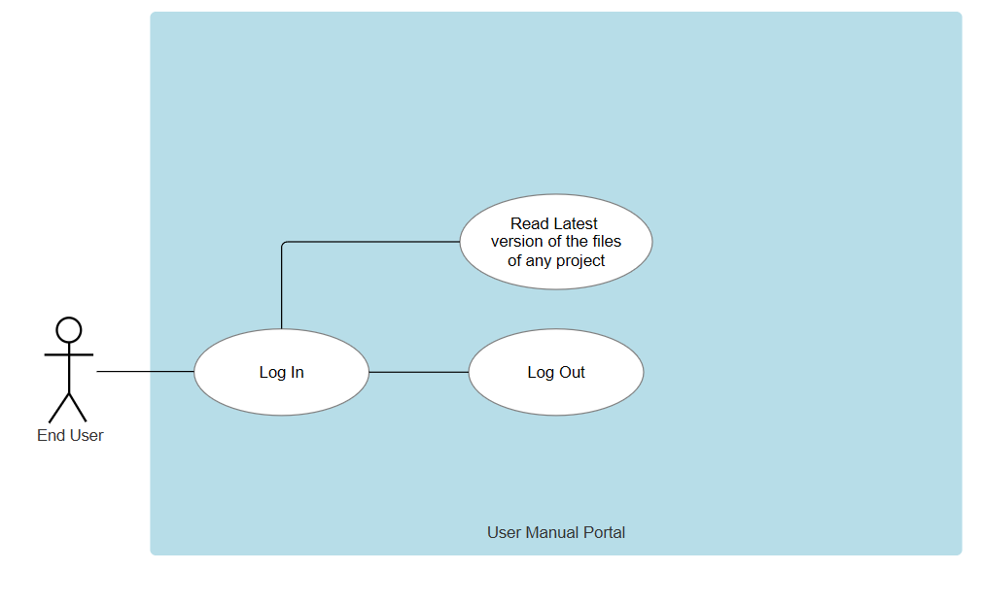Manager Processes: 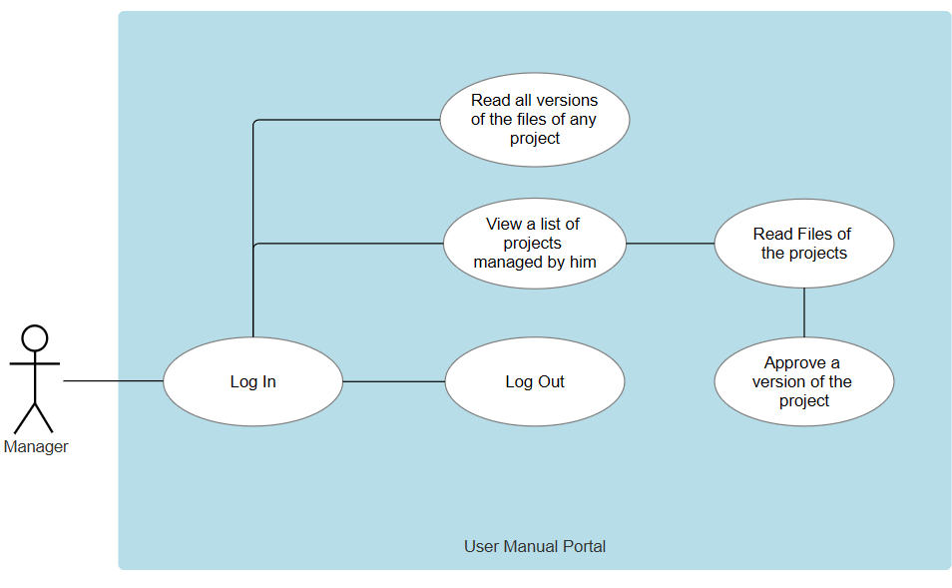Developer Processes: 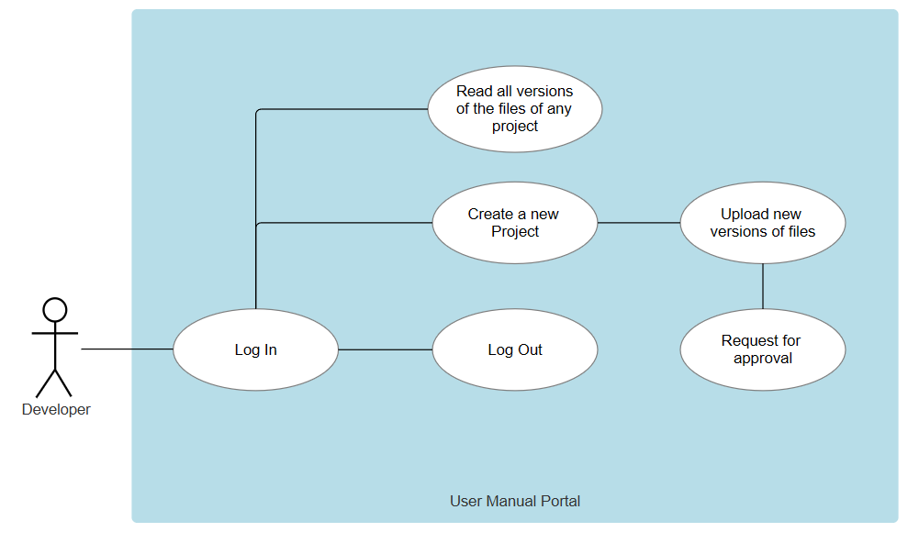

**Resources and Limitations:**

* Personal Laptop is sufficient.
* Documentation of React.js.
* Documentation of Modules which will be used on the website.

**Conclusion**:

* Will increase the efficiency of approval process.
* End users have easy access to the files.
* Will save the manager’s mailbox from being cluttered with multiple approval requests.
* Manager will have a good view of the effort put in by the developer through past versions of the files.